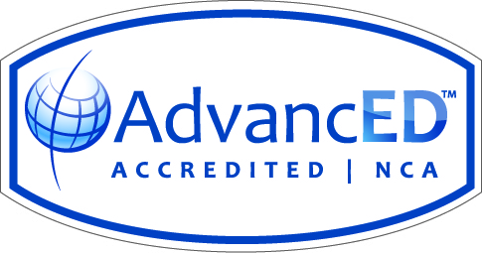
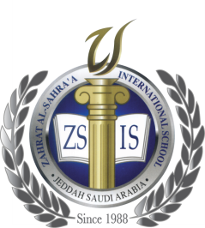
Zahrat Al-Sahra’a International School
Academic Year 2018-2019

Subject :Social Studies (Girls 4 to 12) Date : October 23, 2018
Lessons included: Test # 1/Term 1

Grades | Test # 1 /25 marks
Grade 4 | Unit 1  Lesson 1: What are Traditions?  Lesson 2: What are Customs?  Lesson 3: Our Values
Grade 5 | Unit 1  Lesson 1: Elements of Character  Lesson 2: Growing Up  Lesson 3: Behavioral Problems
Grade 6 | Unit 1 – History of a Nation  Lesson 2: The Beginning of Islam  Lesson 4: The Abbasid Empire
Grade 7 | Unit 1 – World History  Lesson 1: The Mamluks  Lesson 2: The Muslims Conquer India
Grade 8 | Unit 1 – World History  Lesson 1: The Renaissance  Lesson 2: European Expansion
Grade 9 | Chapter 1: Looking at the Earth  Section 1: The Five Themes of Geography  Section 2: The Geographer’s Tools  Chapter 2: A Living Planet  Section 1: The Earth Inside and Out
Grade 10 | Chapter 1: Looking at the Earth  Section 1: The Five Themes of Geography  Section 2: The Geographer’s Tools  Chapter 2: A Living Planet  Section 1: The Earth Inside and Out
Grade 11 | Chapter 2: A Living Planet  Section 1: The Earth Inside and Out  Section 2: Bodies of Water and Landforms  Section 3: Internal Forces Shaping the Earth
Grade 12 | Chapter 2: A Living Planet  Section 1: The Earth Inside and Out  Section 2: Bodies of Water and Landforms  Section 3: Internal Forces Shaping the Earth

